Configuring servers [Running ports 27019, 27020, 27022]

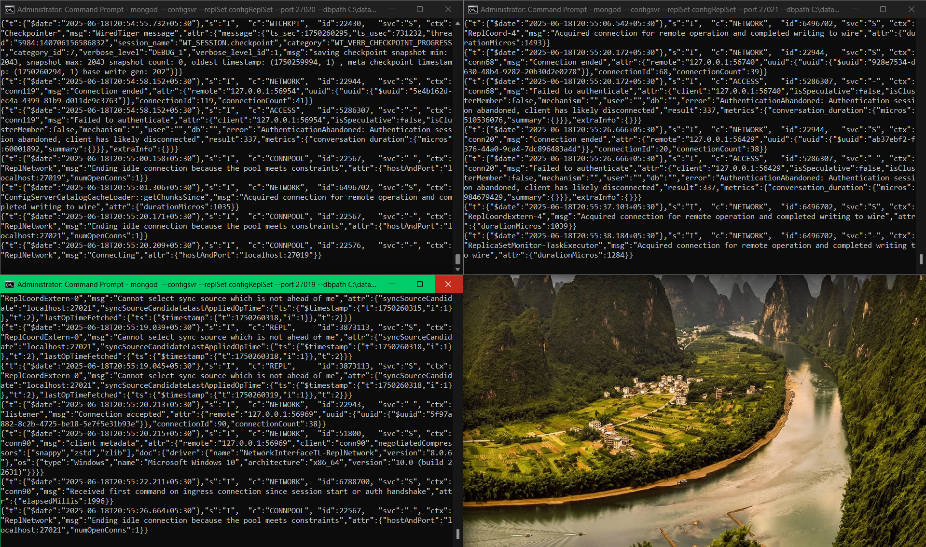

Initializing the config replica set:

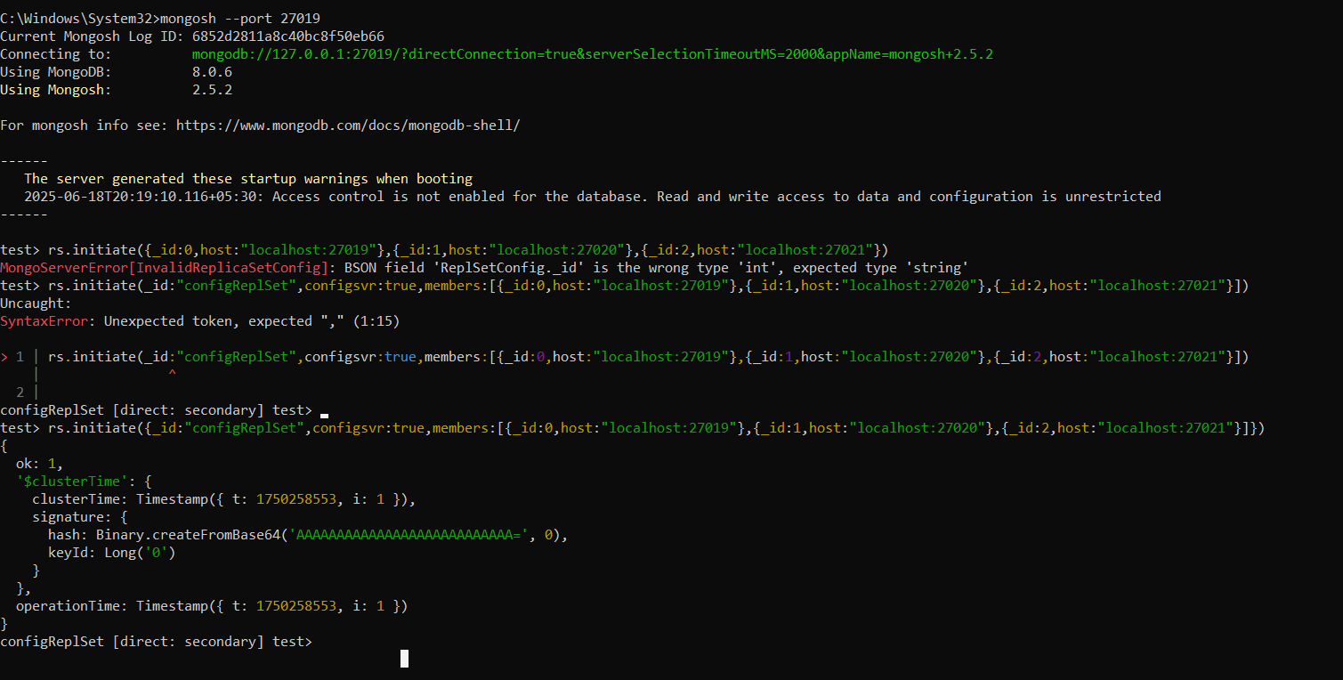

Configuring 3 node of “**Shard1ReplSet”** servers [Running ports 27022, 27023, 27024]

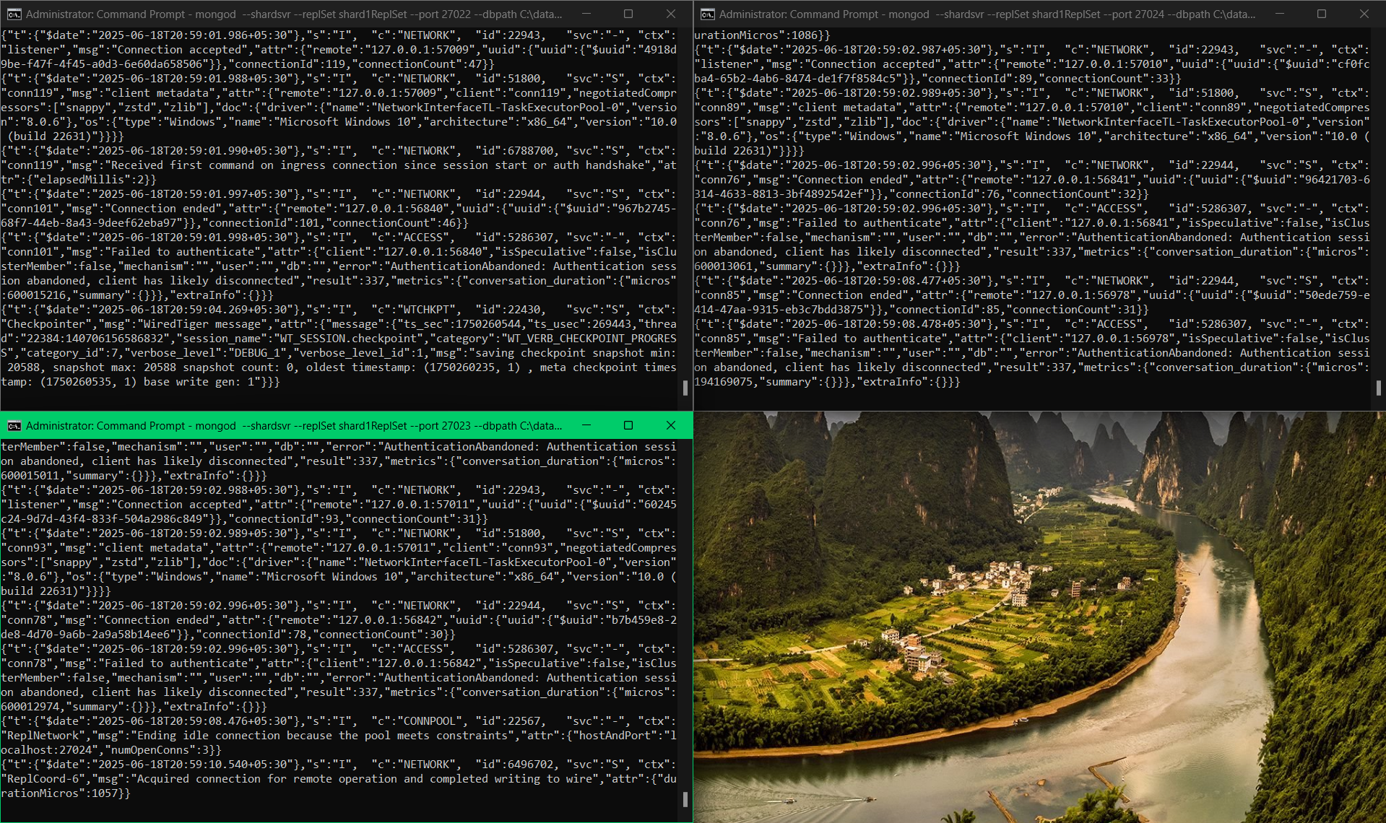

Initializing Shard 1:

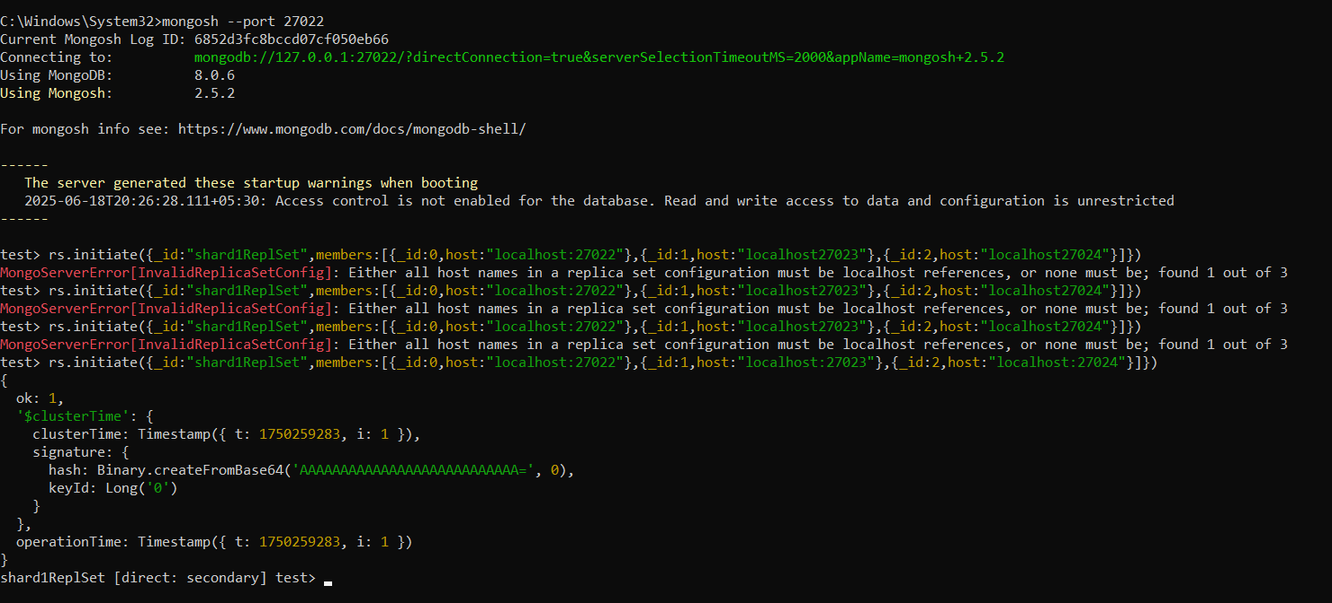

Configuring 3 node of “**Shard2ReplSet”** servers [Running ports 27024, 27026, 27027]

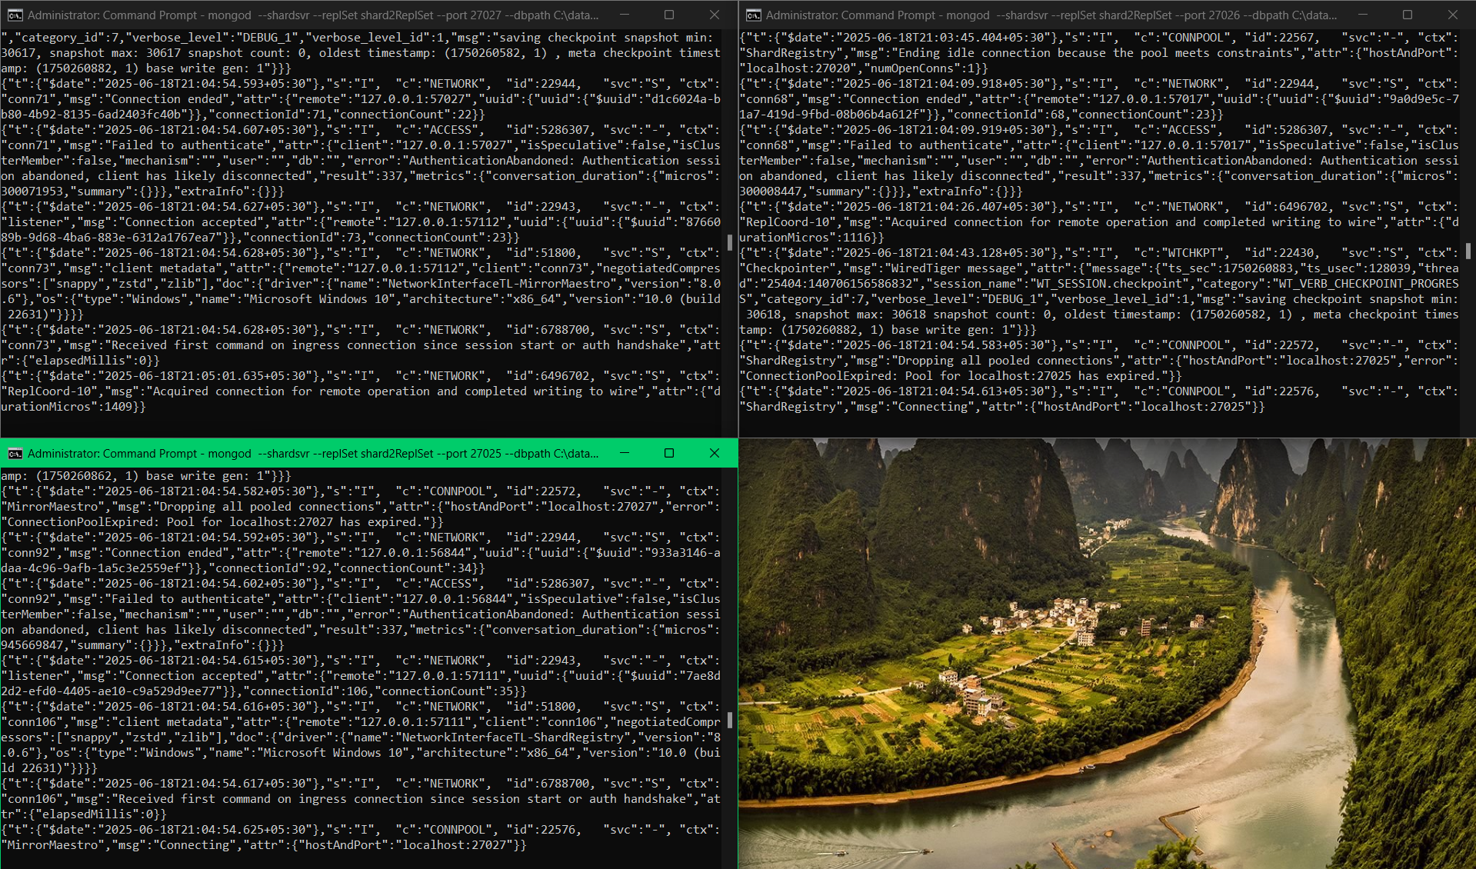

Initializing Shard 2:

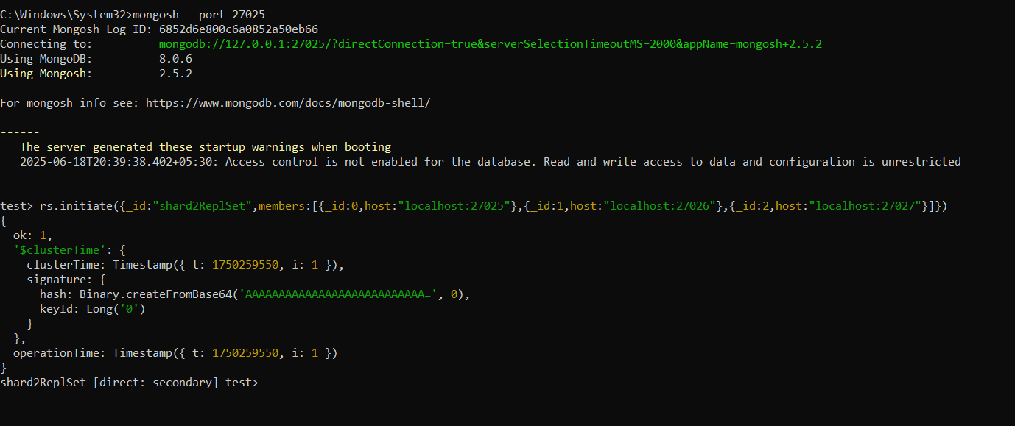

Starting Mongos Query Router

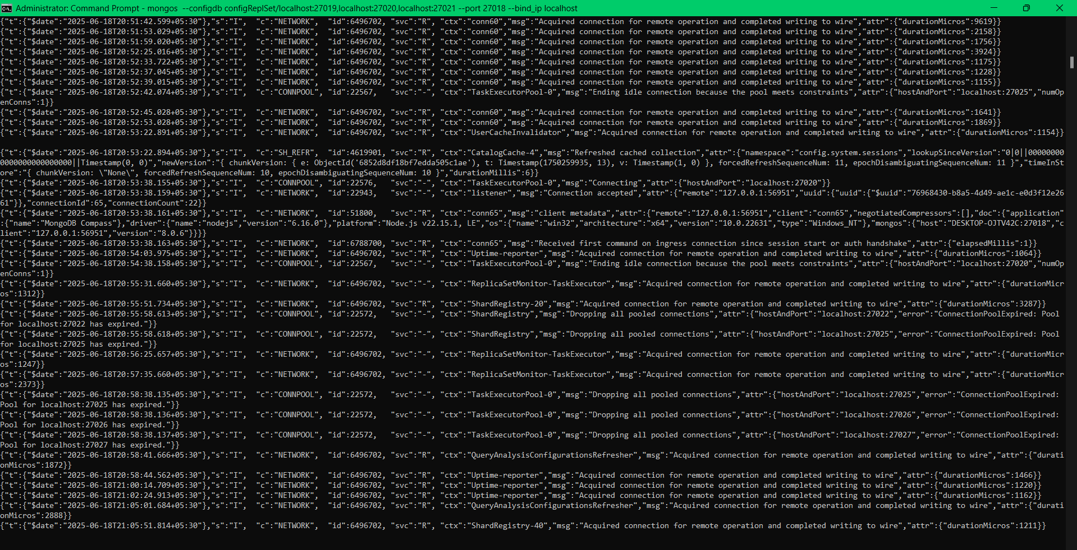

Configuring Sharding

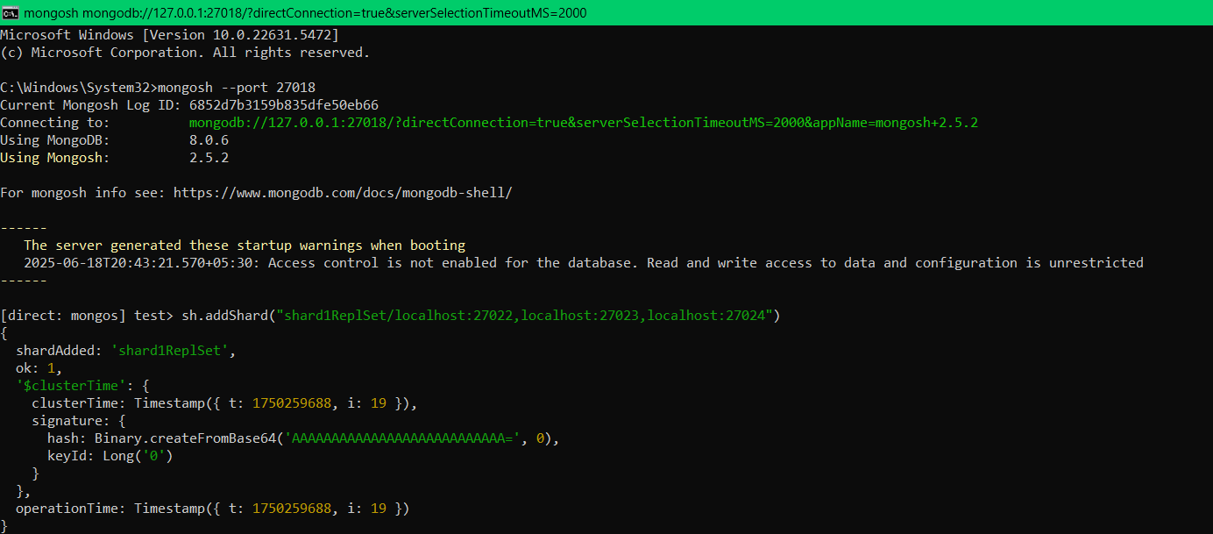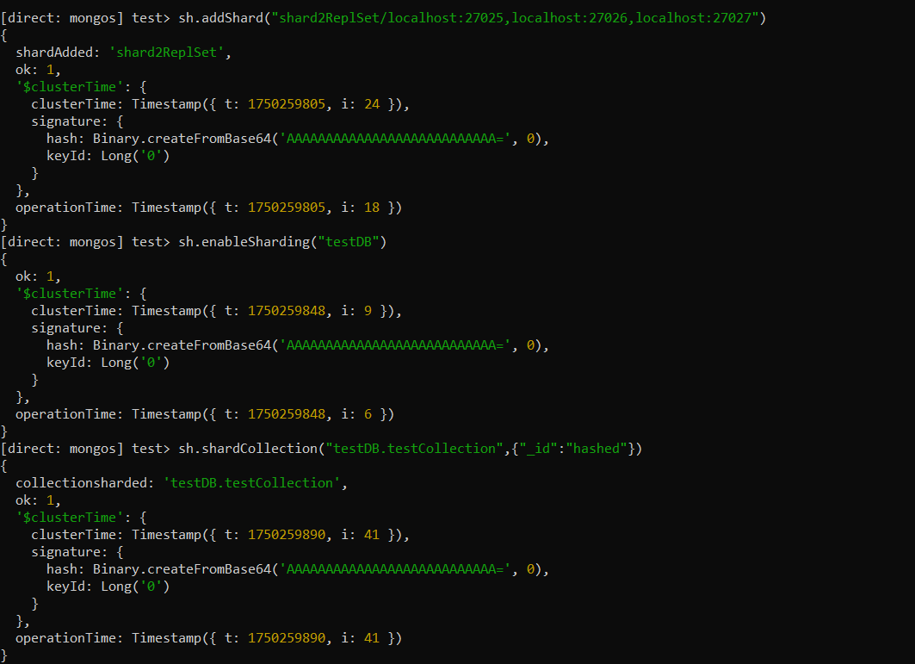

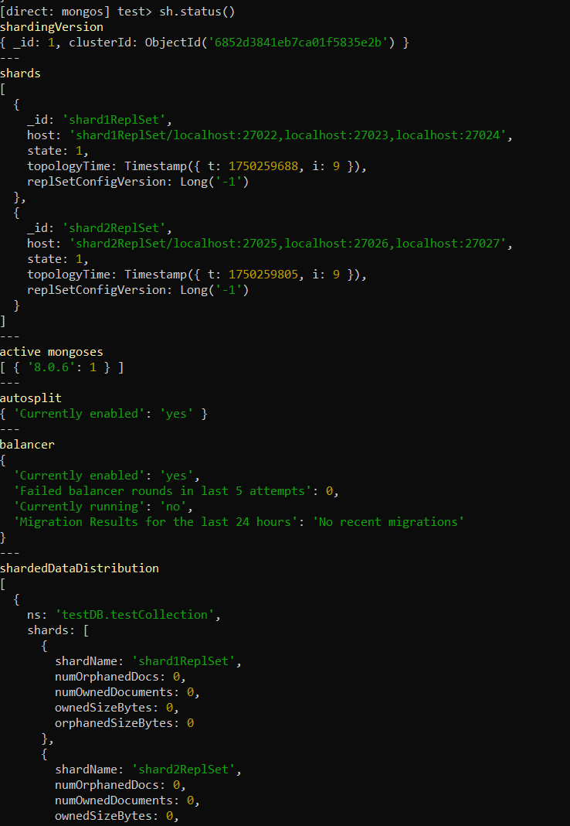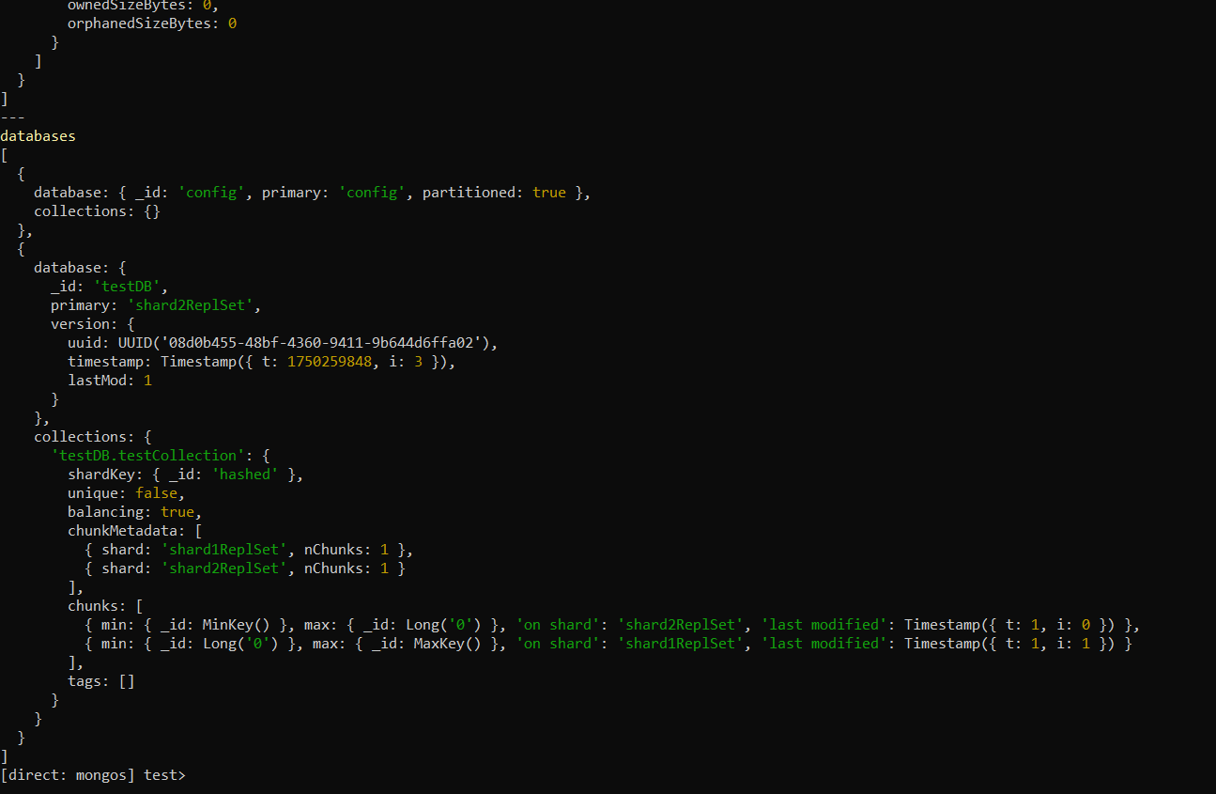

Checking Weather shredding is working or not

